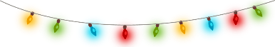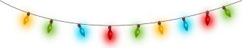

**The Monroe Vision & Revitalization Committee will be hosting a holiday light decoration contest to help spread the festive spirit throughout the community!**

**Entry Information**

Qualifications to Enter: **Resident that Lives within City Limits of Monroe**

Entry Forms: Available at **City Hall** & on the **City’s Website**

Entry Forms Due: **4:00 PM Wednesday, December 19th**

**Contest Information**

When: **Friday, December 21st**, 2018 at 6:00 PM

Where: Meet at City Hall & drive to contestants for light display unveiling.

1st Place Prize: **Festive Gift Basket**

For more information visit:

**ci.monroe.or.us/monroe-area-events-and-activities**

**facebook.com/MonroeOregonUSA**

**Holiday Lights Contest**



**Monroe**